**Round 2**

### Experiment: Dynamics of Four Bar Mechanism

A four bar link mechanism or linkage is the most fundamental of the plane kinematics linkages. It is a much-preferred mechanical device for the mechanization and control of motion due to its simplicity and versatility.[[1](http://engineering.myindialist.com/2009/lab-manual-study-of-inversions-of-4-bar-mechanism-single-and-double-slider-crank-mechanism/#.XT57R-gzZPY)] Basically, it consists of four rigid links which are connected in the form of quadrilateral by four pin joints. If a link completes its full rotation then it’s a crank motion and if it oscillates, the link opposite to the fixed link is the coupler and adjacent to fixed link are input and output link.

The dynamic analysis of the four bar mechanism is covered after understanding the kinematic analysis since the acceleration of the links are required to calculate the forces on the link. The analysis involves the offset analysis, acceleration of CG, forces on each link of four bar mechanism, with the help of position diagram, velocity and acceleration diagram.

**2. Story:**

**2.1 Set the visual stage description:**

On the simulator page a user can observe a motion of position diagram of four bar mechanism with four different colours (brown, blue, red, green) of the link and the pin joint, named in alphabetical manner i.e. A, B, C, D on the top left corner. On top right corner and the middle of the simulator screen a user can observe the velocity diagram as well as acceleration diagram respectively. The velocity diagram is shown with the help of solid colour (as colour of link in position diagram) line and arrow showing direction and magnitude of the links. The link in velocity diagram are named as Vba, Vcb, Vca. The acceleration diagram is also shown with solid colour (as colour of link in position diagram) links showing tangential acceleration, the dotted lines are showing the radial acceleration and thick solid colour lines showing the resultant acceleration. The links in acceleration are named as Ab, Acb, Ac.

On the bottom left corner of the simulator page user can observe a table showing various information of the links such as length, angle between link AB and AD, angular acceleration, velocity magnitude, tangential acceleration magnitude, radial acceleration magnitude and resultant acceleration magnitude. On bottom right corner user can access navigation button to navigate to various other pages of simulator screen.

On the right side a user can observe a variable tab followed by control tab under variable tab. Under the variable tab a user can vary the length of all the links with the help of slider knob. Initially the length of link r1 is set for 80 mm, link r2 for 40 mm, r3 for 80 mm, r4 for 80mm. User can change the angle between the link 1 and 2 with the help of knob under 2 and see the significant change in the motion of the position diagram. under control tab there are four buttons as play/pause, reverse and right left navigation button.

On the next page of simulator screen a user can see the motion of position diagram with the help of arrow indicating the acceleration of center of gravity named as Acg2, Acg3 and Acg4 Under the position diagram, a table is given with the values of acceleration of center of gravity of all the link in the x and y direction. In the control tab a user can navigate to the nest page of variable tab to change the masses of the links named as m2 (kg), m3 (kg), m4 (kg) with the help of slider knob to see the significant change in the motion of position diagram and the values in the result tables.

The next page of the simulator screen shows the offset analysis of the four bar mechanism which is shown with the help of motion of position diagram, which is similar to the position diagram to the first page of simulator screen. User can navigate to this page using the navigation buttons on the simulator page. The offset of each link is shown with double arrow on each link with the name Acg2, Acg3 and Acg4 and Fin2, Fin3 and Fin4 for link 2, 3 and 4 respectively. Under the diagram, user can observe a table displaying the value of the offset of each link. User can see the changes in the value of offset while varying the parameters from variable tab.

The last page of the simulator shows the force analysis of the four bar mechanism, which user can navigate to the page with the help of navigation buttons on the simulator page. On the top left corner user can see the motion of the position diagram. The motion of each link is shown separately with the help of the path trajectory and motion of each link, showing the direction of forces with the help of arrow, on the top right corner and the middle of the screen i.e. link 2, link 3 and link 4 respectively. Under the diagram, the data of the forces of each link is given in both x and y direction. The user can navigate to the third page of the variable tab through the control tab to vary the torque and angle under T4 (Nm) and 2 with the help of slider knob to see the changes in the force data in table and motion of link.

**2.2 Set User Objectives & Goals:**

* Define the concepts of dynamic analysis of four bar mechanisms
* Describe the use of four bar mechanism
* Calculate the velocity and acceleration on each link
* Examine the calculated values with the experimental results
* Evaluate how change in length, angle and driving force results in acceleration, velocity and work done by the mechanism changes

**2.3 Set the pathway activities:**

1. The r1 is set at 80 mm and can be varied from 40 to 80 mm.
2. The r2 is set at 40 mm and can be varied from 20 to 40 mm.
3. The r3 is set at 80 mm and can be varied from 40 to 80 mm.
4. The r4 is set at 80 mm and can be varied from 40 to 80 mm.
5. The 2 can be varied from 0 to 360.
6. Paus the simulation through the control tab.
7. Verify the velocity and acceleration
8. Click on the next button on the simulator screen to navigate to the next the page of the simulator screen.
9. Click on the next button on the simulator screen to navigate to the next the page of the simulator screen.
10. The m1 is set at 0.5 kg and can be varied from 0 to 1 kg.
11. The m2 is set at 0.5 kg and can be varied from 0 to 1 kg.
12. The m3 is set at 0.5 kg and can be varied from 0 to 1 kg.
13. Paus the simulation through the control tab.
14. Verify the acceleration of CG of each link.
15. Click on the next button on the simulator screen to navigate to the next the page of the simulator screen.
16. Paus the simulation through the control tab.
17. Verify the offset analysis results.
18. Click on the next button on the simulator screen to navigate to the next the page of the simulator screen.
19. Click on the next button on the simulator screen to navigate to the next the page of the simulator screen.
20. The T4 (Nm) is set at 0.5 and can be varied from 0 to 1.
21. Paus the simulation through the control tab.
22. Verify the force analysis results.

**2.4 Set Challenges and Questions/Complexity/variation**

**2.4.a Questions before simulation:**

### Which of the following statement is correct as regard to the difference between a machine and a structure?

### A machine transforms the available energy into some useful work, whereas in a structure no energy is transformed into useful work

### The parts of a machine move relative to one another, whereas the members of a structure do not move relative to one another.

### The links of a machine may transmit both power and motion, whereas the members of a structure transmit forces only.

### All the above statement

### Answer: d

### Explanation: None

### A kinematic chain is known as a mechanism when

### Three of the links is fixed

### Two of the links is fixed

### One of the links is fixed

### None of the above

### Answer: c

### .

### The Grubler’s criterion for determining the degrees of freedom (n) of a mechanism having plane motion is

### N= 4(l-1)-3j

### N= 3(l-1)-2j

### N= 2(l-1)-2j

### N= (l-1)- j

### Answer: b

### What is the use of beam engine?

### To convert oscillatory motion into rotary motion

### To convert rotary motion into oscillatory motion

### To convert rotary motion into reciprocating motion

### To convert reciprocating motion into rotary motion

### Answer: c

### How many revolute joints are there in a four bar mechanism

### 1

### 4

### 6

### 8

### Answer: b

**2.4.b Questions after simulation:**

### **Which of the following is an inversion of four bar kinematic chain?**

### **Reciprocating engine**

### **Rotary engine**

### **Oscillating Engine**

### **Beam engine**

### **Answer: a**

### “Inversions of Four Bar Chain”.

### Match list 1 with list 2

|  |  |
| --- | --- |
| List 1 | |
| A | Quick return Mechanism |
| B | Apron mechanism |
| C | Indexing mechanism |
| D | Regulating wheel |

|  |  |
| --- | --- |
| List 2 | |
| 1 | Lathe |
| 2 | Shaper |
| 3 | Milling machine |
| 4 | Centreless grinding |

### A-3, B-2, C-1, D-4

### A-2, B-1, C-3, D-4

### A-4, B-2, C-3, D-1

### A-2, B-3, C-4, D-1

### Answer: b

1. What is the Grashof linkage criterion?
2. s+l>p+q
3. s+l<p+q
4. s+p>l+q
5. s+p<l+q

Answer: B

1. How many equations in total are formed in the process of finding out the forces on each link?
2. 3
3. 6
4. 9
5. 12

Answer: C

1. How many forces are acting on each link due to other links?
2. 2
3. 3
4. 4
5. 5

Answer: A

1. What is the order of analysis of the four bar linkage?
2. Position analysis, Velocity analysis, Dynamic Analysis, Acceleration analysis
3. Dynamic Analysis, Acceleration analysis, Position analysis, Velocity analysis
4. Position analysis, Velocity analysis, Acceleration analysis, Dynamic Analysis
5. Dynamic Analysis, Position analysis, Velocity analysis, Acceleration analysis,

Answer: C

1. How many degrees of freedom does a four bar mechanism have?
2. 0
3. 1
4. 2
5. 3

Answer: B

1. What is the shortest link for the following category of four bar mechanism?
2. Double crank (s + l < p + q)
3. Double rocker (s + l < p + q)
4. Frame and coupler
5. Frame and side
6. Coupler and side
7. Coupler and frame

Answer: a

**2.5 Allow pitfalls: NA**

**2.6 Conclusion:**

Time required to perform the virtual experiment.

The approximate time required to understand the procedure to perform the experiment would take about 5 min. The time required to understand the relation between the kinematic and dynamic analysis if four bar mechanism will take around 5 minutes. The time required for calculation is around 10 minutes. The time required to compare the results with the simulation will take around 5 minutes. Thus, the total time required to perform the experiment will require approx. 25 min.

**2.7 Equations/formulas:**

**Dynamic force Analysis of a 4 – link mechanism.**

OABC is a 4–bar mechanism. Link 2 rotates with constant angular velocityω2. G2, G3& G4 are the center of gravity and M1, M2& M3 the masses of links 1, 2 & 3 respectively.

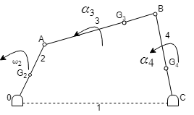

What is the torque required, which, the shaft at o must exert on link 2 to give the desired motion?

1. Draw the velocity & acceleration polygons for determine the linear acceleration of G2, G3& G4.
2. Magnitude and sense of α3&α4 (angular acceleration) are determined using the results of step 1.

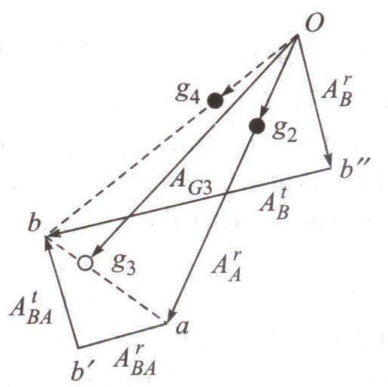

**To determine inertia forces and couples**

**Link 2**

F2 = accelerating force (towards O)

*Fi*2= inertia force (away from O)

Since ω2 is constant, α2 = 0 and no

inertia torque involved.

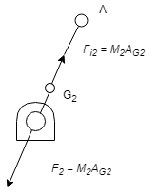

***Link 3***

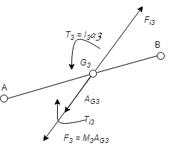

Linear acceleration of G3 (i.e., AG3) is in the direction of *Og*3 of acceleration polygon.

*F*3= accelerating force

Inertia force *Fi*3' acts in opposite direction. Due to α3, there must be a resultant torque T3 = I3α3 acting in the sense of α3 (I3 is MMI of the link about an axis through G3, perpendicular to the plane of paper). The inertia torque *Ti*3 is equal and

opposite to T3.

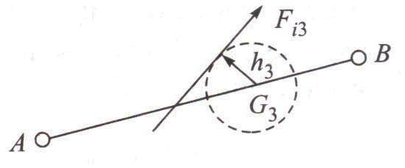

|  |  |  |  |  |  |  |  |  |  |  |
| --- | --- | --- | --- | --- | --- | --- | --- | --- | --- | --- |
| *F* | can replace the inertia force | *F* ' | and inertia torque *T* | . *F* is tangent to circle of radius h3 | | | | | |  |
| *i* 3 |  | *i* 3 | *i* 3 | *i* 3 |  |  |  |  |  |  |
| from G3, on the top side of it so as to oppose the angular accelerationα3. | | | | | *h*3 | *I* | 3*α* | 3 |  |  |
|  |  |  |  |  |

*M* 3 *AG*3

**Link 4**

|  |  |  |  |  |
| --- | --- | --- | --- | --- |
| *h*4 | *I* | 4*α* | 4 |  |
|  |  |  |  |

*M* 4 *AG*4

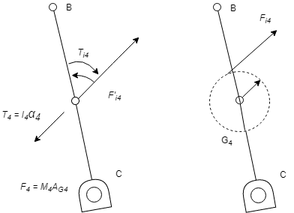G4

**3. Flowchart:**

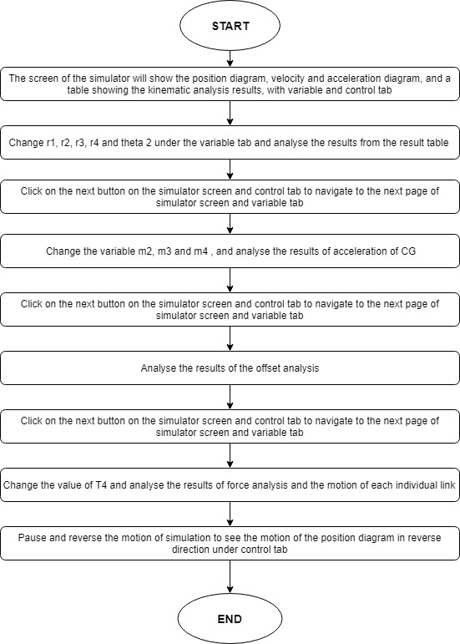

1. **Mindmap:**

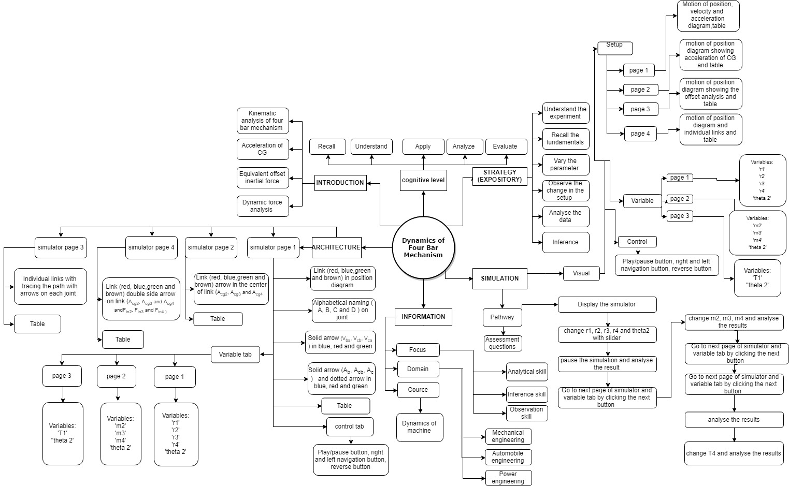

1. **Storyboard:**
   1. In simulation window the motion of position diagram, velocity and acceleration diagram is shown.
   2. There are pointers given on right side of the screen under the variable tab to change the values of r1, r2, r3, r4 and theta 2, and navigation, play/pause and reverse button under control tab. Navigation buttons given on the simulator screen for the navigation of the simulator screen.

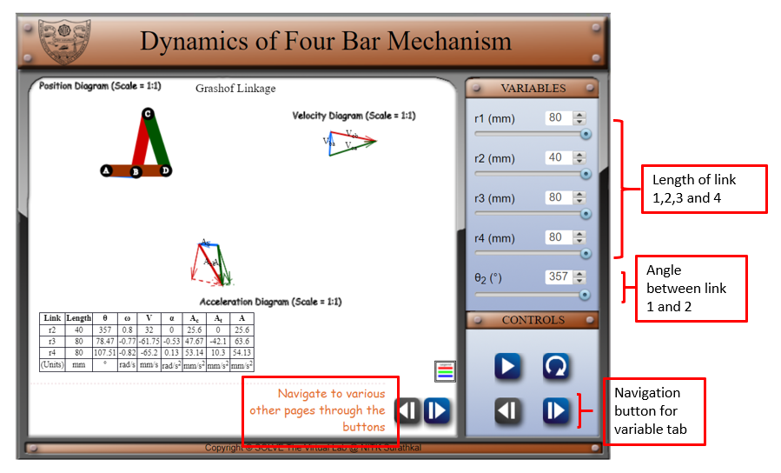

* 1. After moving on to the next page of simulator screen and variable tab, change value of m2, m3, m4 of the link, the acceleration of center of gravity of the link is shown.

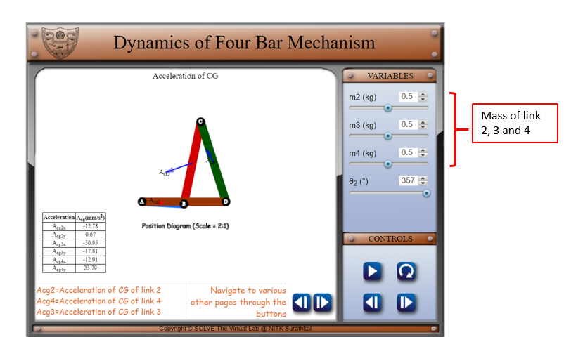

1. Navigate to the next page of the simulator screen. And analyse the offset analysis results from the table after pausing the animation,

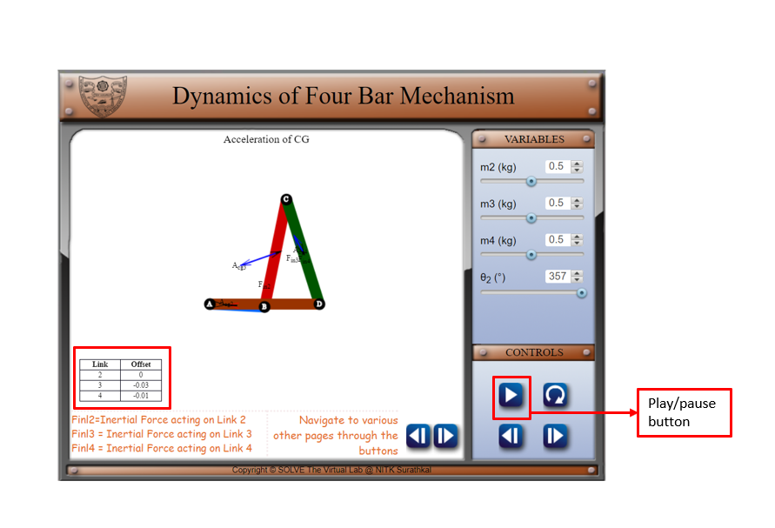

1. Navigate to the next page of simulator screen and variable tab and change T4, and reverse the animation using the control tab, in simulator observe the force acting on each link.

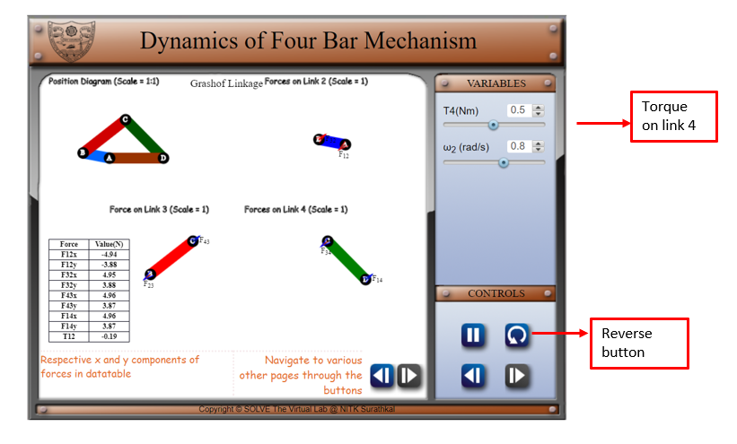

RESFERENCE: [1] <http://engineering.myindialist.com/2009/lab-manual-study-of-inversions-of-4-bar-mechanism-single-and-double-slider-crank-mechanism/#.XT57R-gzZPY>